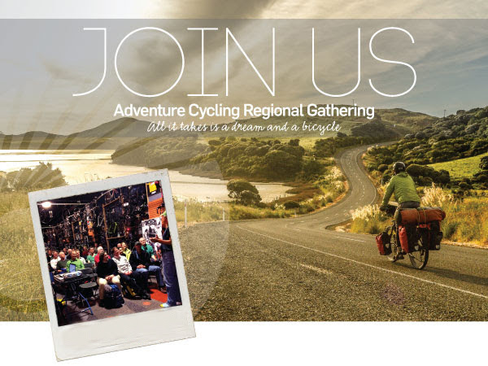
Dear Reston Bicycle Club,
Join Adventure Cycling Association, the Reston Association, and the Reston Bike Club for a special gathering at Reston Association Conference Center on Sunday, March 6, with Adventure Cycling staff members Ginny Sullivan and Saara Snow. Enjoy snacks and refreshments courtesy of the Reston Association, Reston Bike Club, and the Friends of the W&OD Trail.
Meet kindred cycling spirits, learn the latest about bike travel and cycling in North America — including exciting events planned for Adventure Cycling’s 40th anniversary: National Bike Travel Weekend, June 3–5, the Montana Bicycle Celebration, July 15–17, and Bike Your Park Day on September 24. Ginny and Saara will also highlight our tours program, membership, new routes, progress on the U.S. Bicycle Route System, and other national advocacy projects. Special presentations by local cycling organizations will round out the agenda. Two of your favorite local bike shops will be on hand to help you get on the road!
When: Sunday, March 6 from 3:00 to 5:30 pm (the program will begin at 3:30 pm)
Where: Reston Association Conference Center, 12001 Sunrise Valley Drive, Reston, VA
Directions: Approach from DC: use 267 (Dulles Toll Road) to Reston Parkway Exit. Head south on Reston Parkway. Turn right at Sunrise Valley Drive. Turn left at first light, turn left into Reston Association parking lot.
Metro/Biking Directions from DC: Use Metro/W&OD to Wiehle-Reston East station. Take W&OD west to Reston Parkway exit. Cross Reston Parkway at light, turn left onto multi-use trail that runs on west side of Reston Parkway. Stay on trail to Sunrise Valley Drive. Cross Sunrise Valley, then enter Reston Association parking lot near corner. Bike parking in front of the building.
Please RSVP at info@adventurecycling.org or (406) 532-2751 by March 3.
We look forward to seeing you in Reston!
A bit about our hosts: Reston, VA, the only designated Bicycle Friendly Community in Fairfax County, is home to over 100 miles of paved and natural trails. Bisected by the W&OD Trail, the Gerry Connolly Cross Country Trail, the Fairfax County Parkway Trails, and providing a gateway to mountain biking trails at Lake Fairfax, Reston offers something for every kind of cyclist. Local biking organizations can help you plan a ride, a day trip, or even an adventure, and fill you in on what's going on in local advocacy to enhance the roads and trails in our area.
Volunteer? Can you lend a hand? We are looking for a volunteer or two to help by prepping the gathering location and cleaning up. Please contact me at info@adventurecycling.org or (406) 532-2751, if you are interested.
Beth Petersen
Member Services Manager
Adventure Cycling Association
Inspiring and empowering people to travel by bicycle
www.adventurecycling.org
Phone: 800-755-2453

